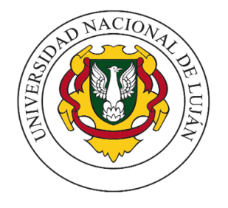
UNLu APPLICATION INSTRUCTIVE
FOR FOREIGN STUDENTS

Those foreign students who wish to study an academic period at the National University of Luján, must perform the following steps:

1 – Verify that there is an Agreement between the University of Origin and the UNLu or that both Institutions participate / have a common Mobility Program.
2 – Search for your career (or a similar one) on the UNLu page: www.unlu.edu.ar and then search for the contents (programs) of the subjects you wish to take on the following page: www.certificaciones.unlu.edu.ar
3 – Once you have analyzed the possible equivalences, you should contact the Academic Coordination at your University of Origin, to validate or modify the equivalences of the previous point and to be able to prepare the application form with your corresponding Study Contract.
4 – You should contact the International Relatioships Office of your University, so that they institutionally apply for it to the email: relint@unlu.edu.ar
5 – If in any part of the process you need help from UNLu, you can communicate by mail to the mail cited in point 4 and will be gladly guided to continue with your paperwork.

